Name: ____________________________________ Proving the Solution Set for Inequalities (T/F)
Directions: State all of the values of the variable for when the following equation/inequalities will be true and when they will be false.
- Fill in each row of the table below.
Ashley wants to get a new pair of shoes. Let s represent the cost of one pair of shoes.
Situation | What does this mean? | Value for s that makes the statement TRUE | Value for s that makes the statement FALSE
s = 40
s < 40
s ≥ 40
4s ≤ 160

- g + 25 ≥ 60

True: ______________________________________________________________________________________

False: _____________________________________________________________________________________

- $\frac{j}{5}$ = 17

True: ______________________________________________________________________________________

False: _____________________________________________________________________________________

- $6f$ ≤ 54

True: ______________________________________________________________________________________

False: _____________________________________________________________________________________

- $\frac{k}{4}$ > 8

True: ______________________________________________________________________________________

False: _____________________________________________________________________________________
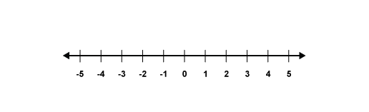
Name: ____________________________________ Writing & Graphing Inequalities
- Inequality: x ≥ -2

- Inequality: x < 4

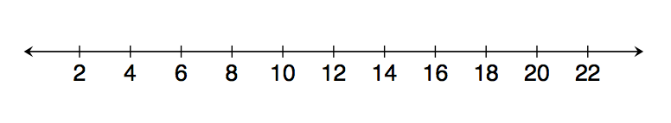
- Inequality: m ≤ 17

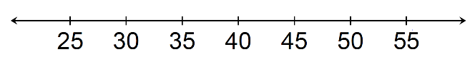
- At least 35

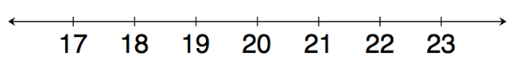
- No more than 20

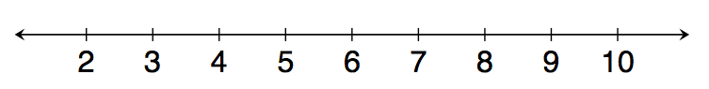
- Less than or equal to 8

- Inequality: h ≤ 525

- Fewer than 8

- Inequality: 225 ≥ h

- Inequality: x < 12

Name: ____________________________________ Substitution
Directions: Substitute the indicated value of the variable, and state whether the resulting number sentence is true or false. If true, find a value that would result in a false number sentence. If false, find a value that would result in a true number sentence.
- 45 ≤ 24 + x. Substitute 31 for x.
___________________________________________
- 56 = 7y. Substitute 9 for y.
___________________________________________
- $\frac{g}{5}$ > 8. Substitute 40 for g.
___________________________________________

- k – 17 < 32. Substitute 50 for k.
___________________________________________

Directions: Choose the numbers, if any, that make the equation or inequality true from the following set of numbers: {0, 2, 5, 9, 12, 16}

- 6f ≥ 48

- $\frac{1}{2}$ x < 6

- g + 12 >15

- 22 – x = 10

Name: ____________________________________ Writing & Solving Inequalities REAL-WORLD PROBLEMS
Directions: Write an inequality to represent each of the following situations. Then, graph the inequality on the number line.
1. Senior citizens 65 years and older receive a discount at the Country Buffet. Let d represent the age of a citizen who receives the discount.
_______________________________

2. I can spend no more than $12 at Chipotle. Let m represent the amount of money I can spend.
________________________________

3. Daniel’s mom asked him to pick out a birthday present for his brother. She said he should spend a minimum of $20 but no more than $50 on his present. Let d represent the number of dollars Daniel could spend on his brother’s birthday present.
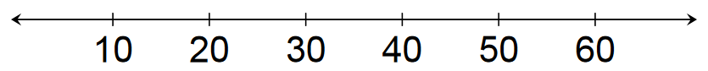
________________________________

4. Harry’s mom is taking him back to school shopping. His mom says that she will buy him a minimum of 8 items, but less than 20 items. Let n represent the number of items Harry’s mom will buy her?
________________________________

5. Bob’s dad said he can go to his cousins’ house for a minimum of 45 minutes, but a maximum of 70 minutes. Let m represent the number of minutes Bob can be at his cousins’’ house.
_________________________________

6. The maximum weight that an elevator can hold is, at most, 3,400 pounds. A group of people weighing 560 pounds enter the elevator.
a.) Write an inequality to show how many more pounds the elevator could carry.

________________________________________

b.) Could 5 people, each weighing 150 pounds, fit on the elevator? Prove your answer!!

_________________________________________________

7. On a mystery game show there are 3 boxes with equal amounts of money. The game show hosts says that in total, the three boxes have at least $4,500 in them.
a.) Write an inequality to represent the amount of money in each box. Use b to represent the amount of money in each box.
______________________________________
b.) Can each box have $1,250? Prove your answer using any method.

________________________________________

8. Kayla’s teacher tells her that her homework should take at most 45 minutes. Kayla has been working on her homework for 17 minutes. She writes the inequality to represent her situation, 45 ≥ 17 + x, where x represents the time left to work.

Do you agree with Kayla’s inequality? If yes, prove Kayla’s inequality using substitution. If not, help Kayla to fix it. ______________________________________________________________________________________________________________________________________________________________________________________________________________________________________________________________________________________________________

9. Write your own word problem to represent a double inequality.
_____________________________________________________________________________________________________________________________________________________________________________________________________________________________________________________________________________________________________

